**ASSIGNMENT - 9**

**PROBLEM STATEMENT** - Deploy a project from GitHub to EC2.

**To Deploy the project**

STEP 1- Select EC2 option.

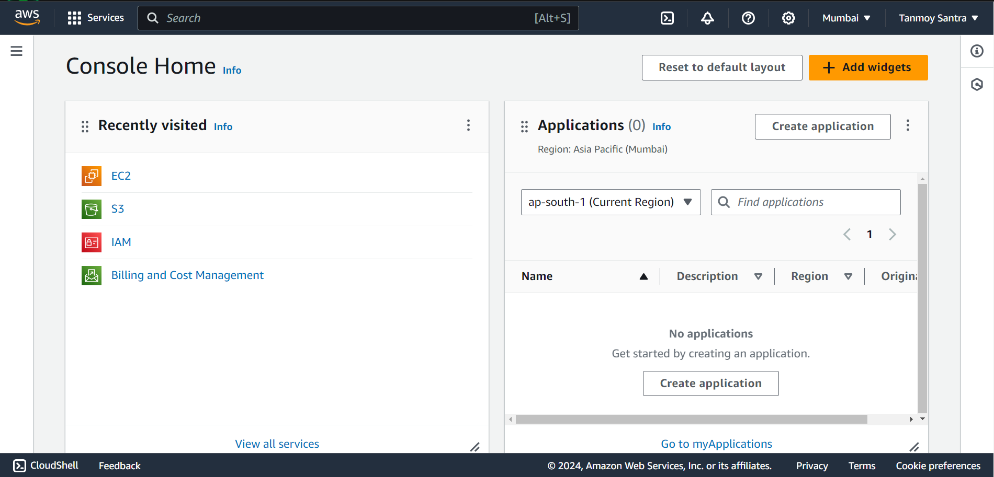

STEP 2- Click on Launch Instance.

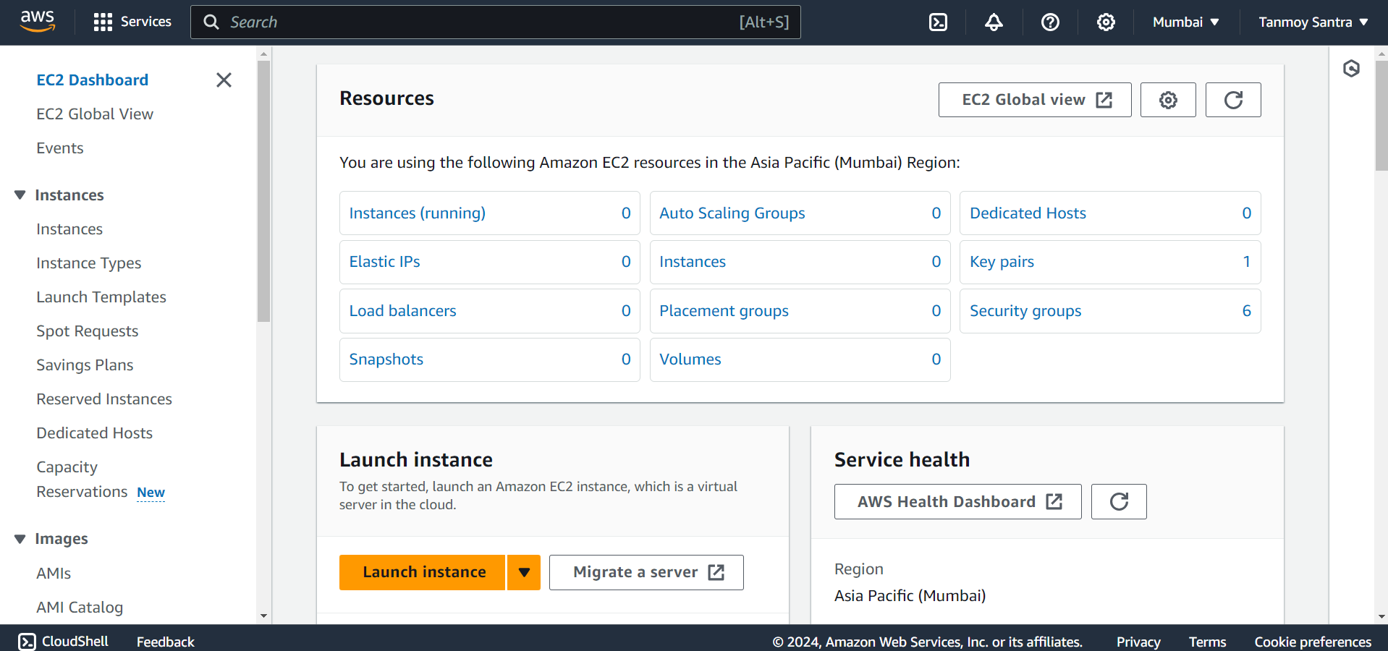

STEP 3- Give a unique name to the instance and select Ubuntu.

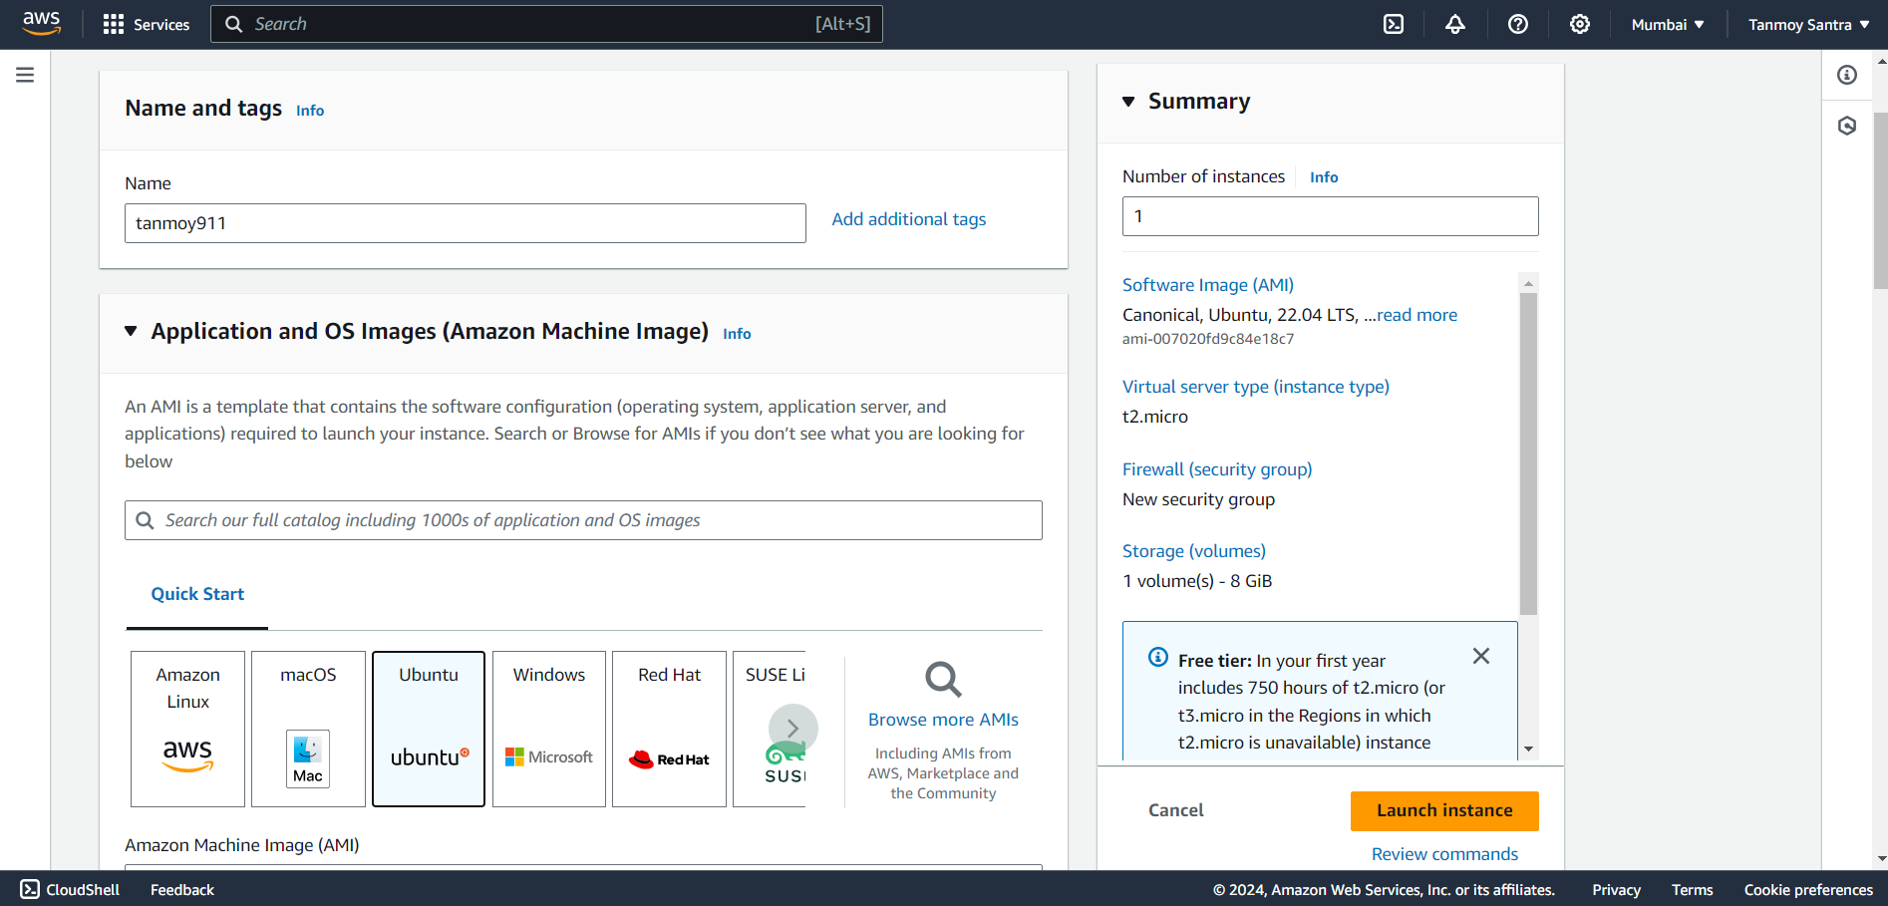

STEP 4- Select the key from the list or create a new one.

STEP 5- Check all the 3 check boxes. Then click on Launch Instance.

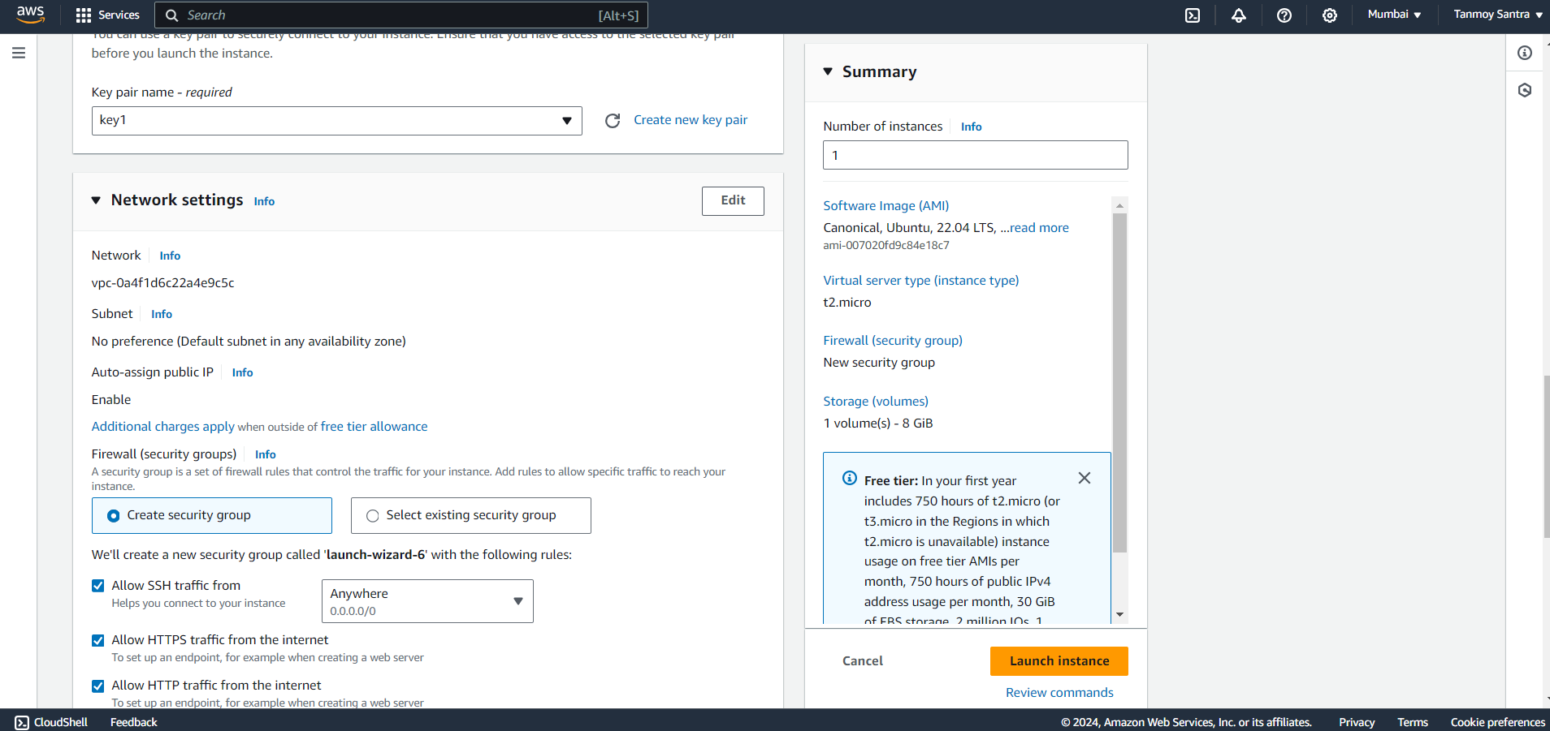STEP 6- Click on instance id to enter into the instance.

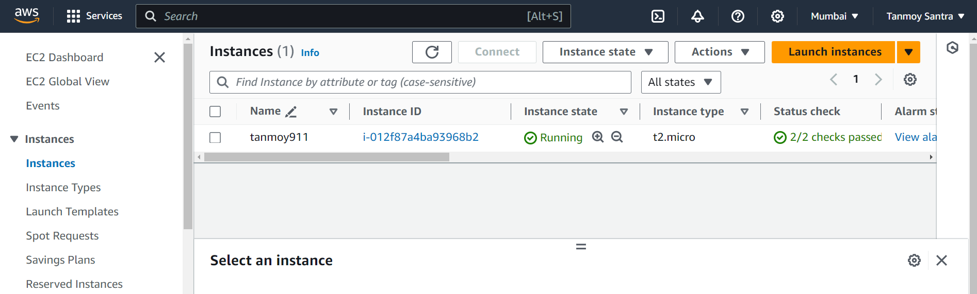

STEP 7- Select the Security option & Click on the security group ID.

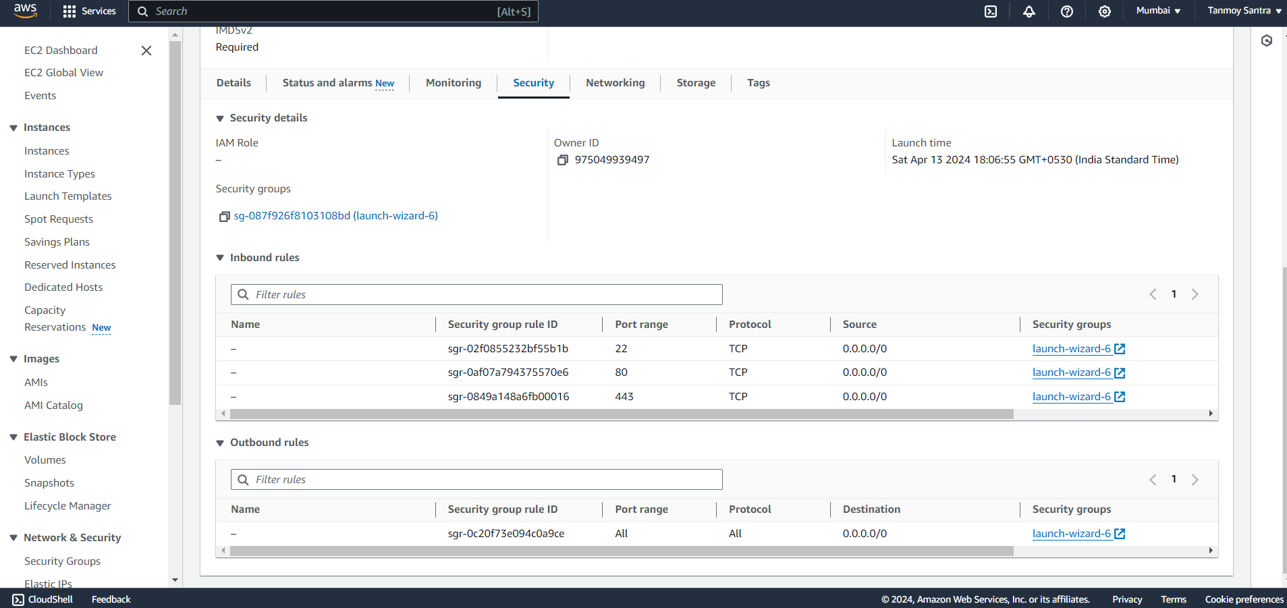

STEP 8-Click on Edit Inbound Rules.

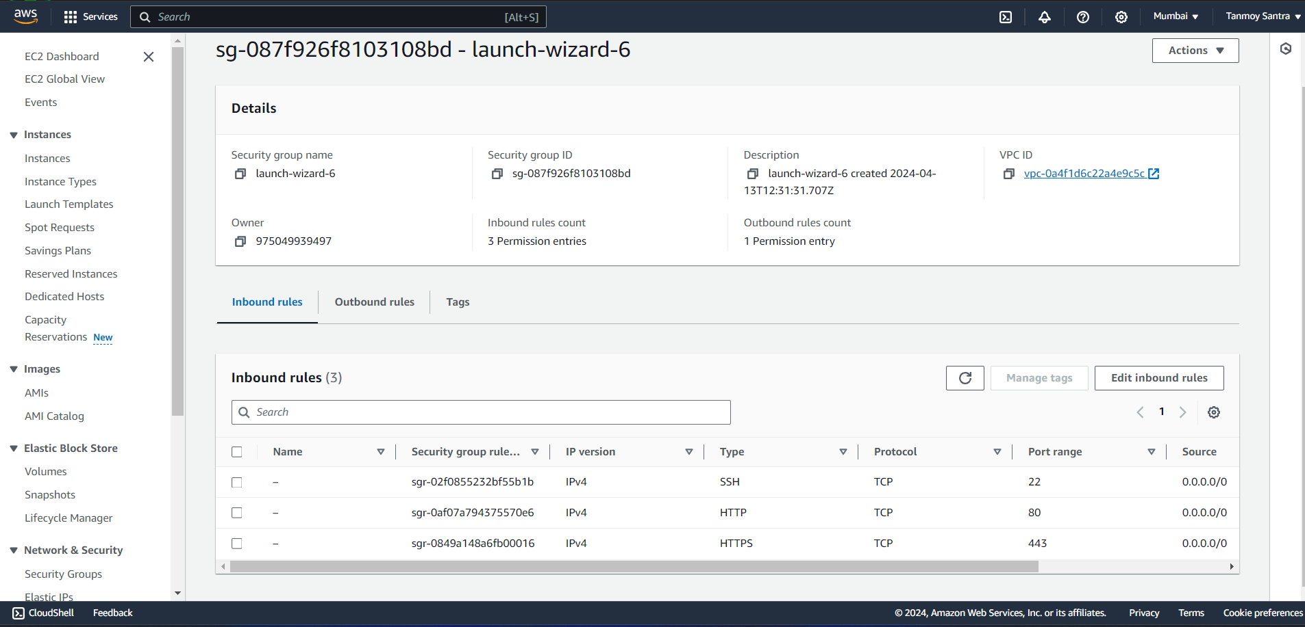

STEP 9- Click on Add Rules.

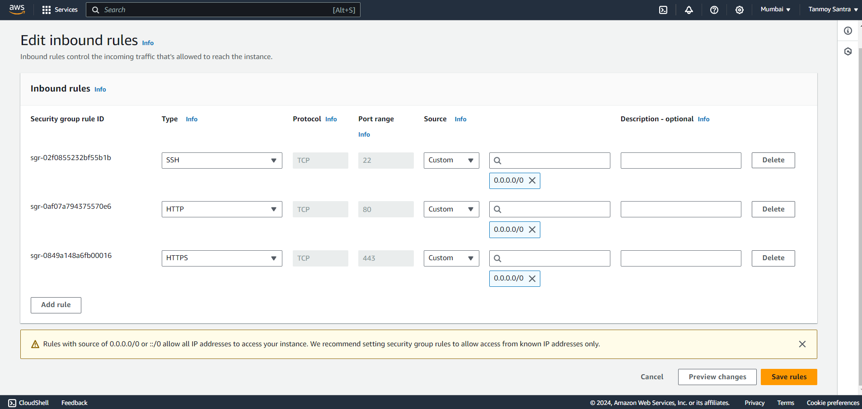

STEP 10- Give the port no. 4000, in source info give 0.0.0.0/0. Then click on Save Rules.

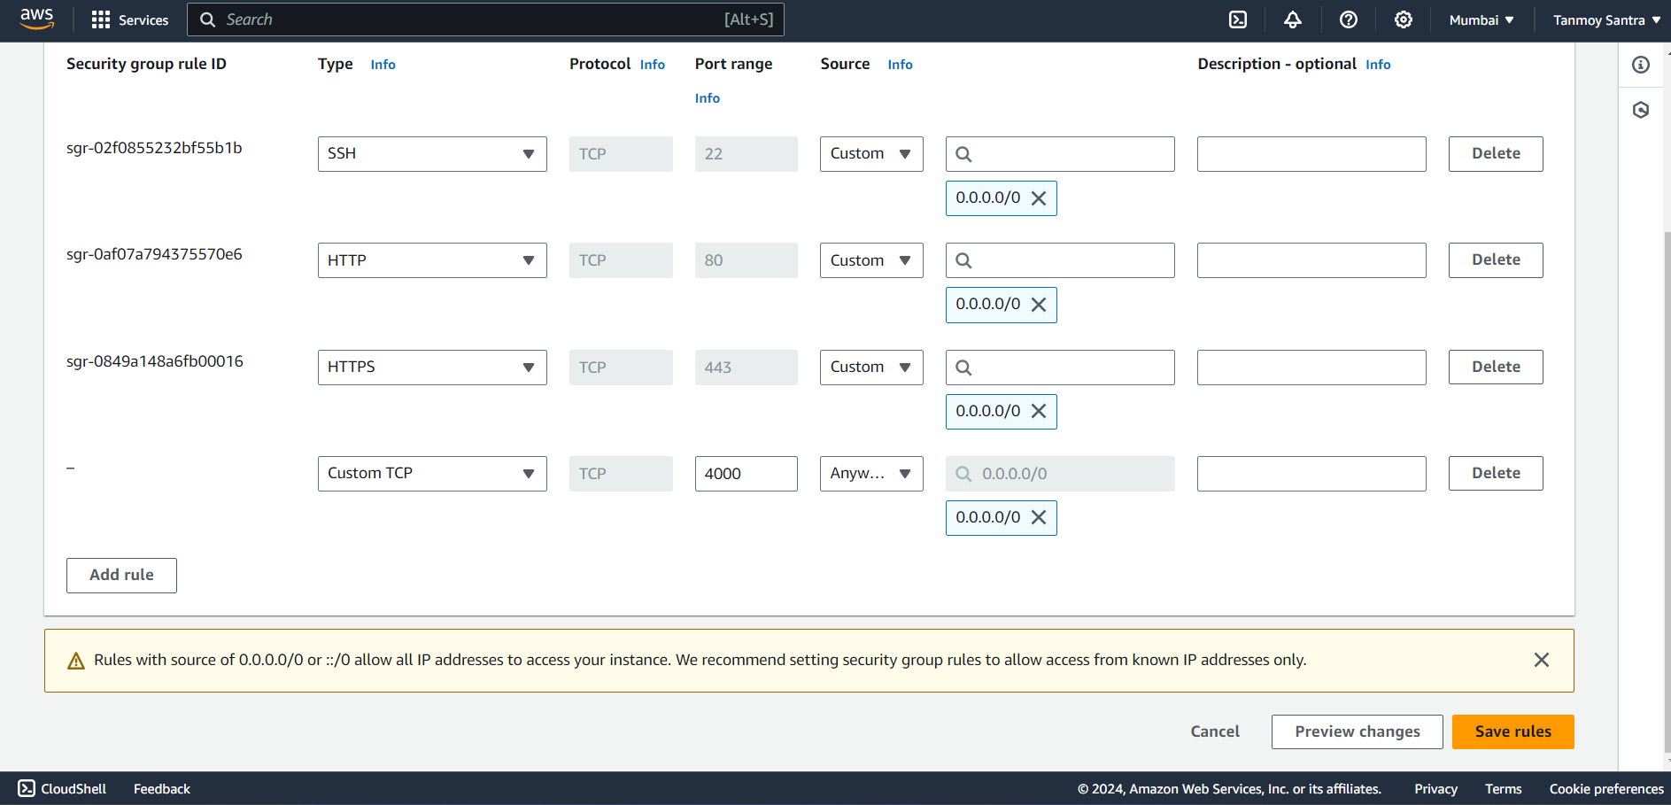

STEP 11- Go back into the instance and copy the Public IPv4 Address.

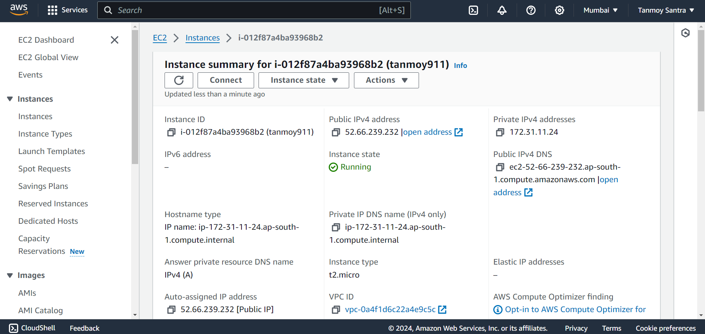

STEP 12- Open Bitvise SSH Client, Paste the address under the host tab. Under the Authentication tab, give the username as ubuntu, Initial method as publickey. Then click on Client Key Manager.

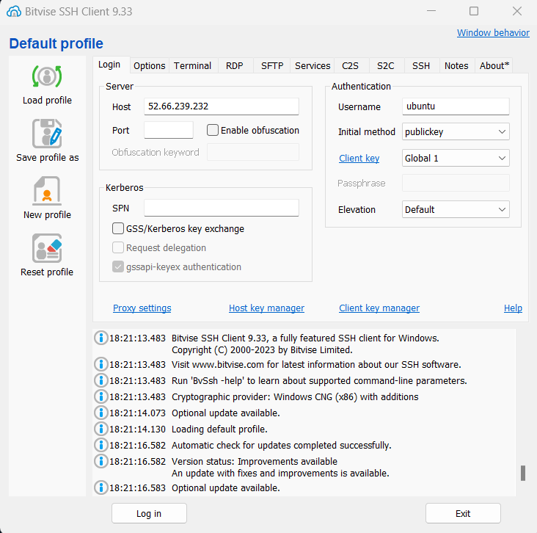

STEP 13- Remove any previously selected key if any, then click on Import.

STEP 14- Select the key using which instance was created. Then close the window.

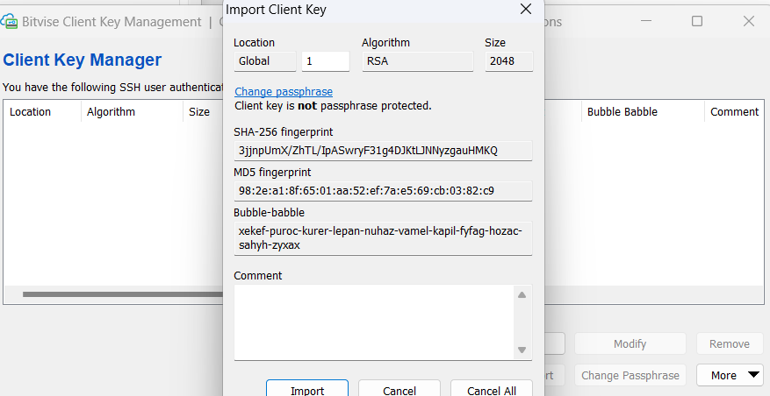

STEP 15- Click on Login.

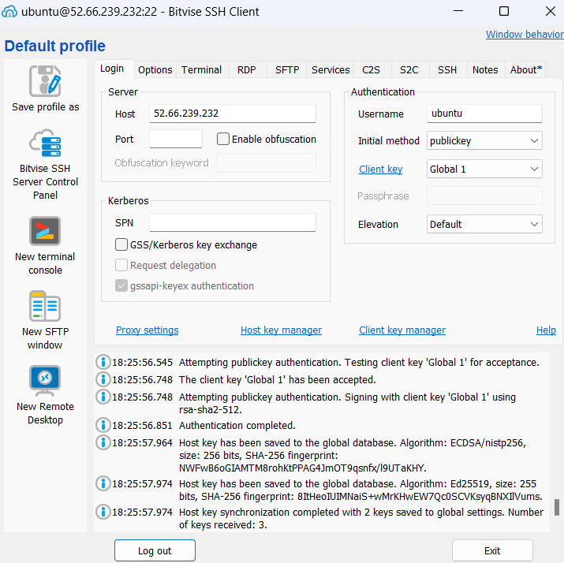

STEP 16- Open a new terminal by clicking on New Terminal Console.

STEP 17- In the console type the following commands in sequential order:

sudo apt-get update

sudo apt-get upgrade

sudo apt-get install nginx

sudo apt install nodejs

git clone

cd awsass2

npm install

node index.js

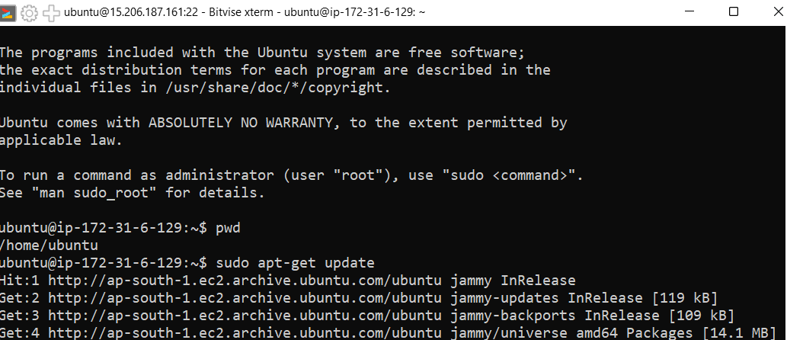

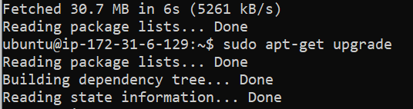

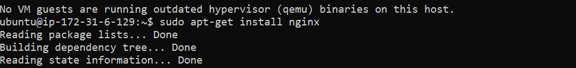







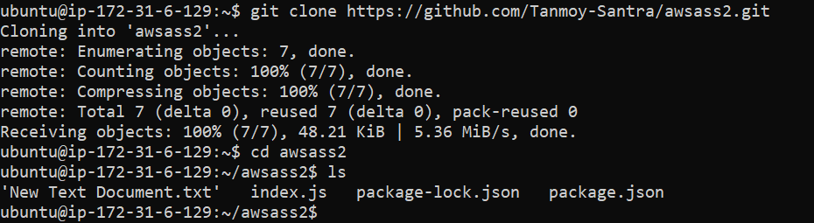

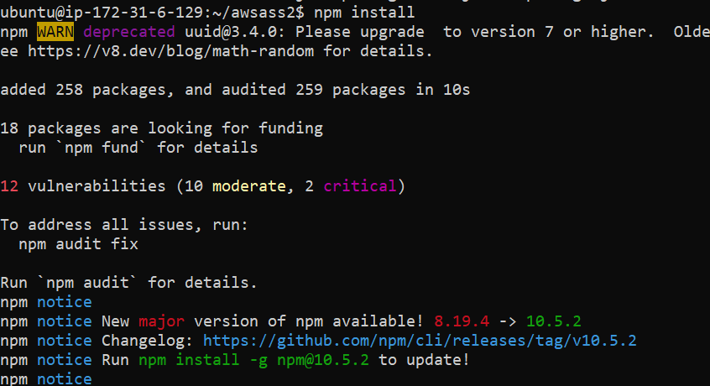

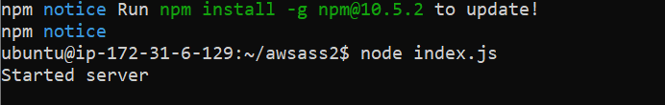

STEP 18- From the Public IPv4 Address click Open Address.

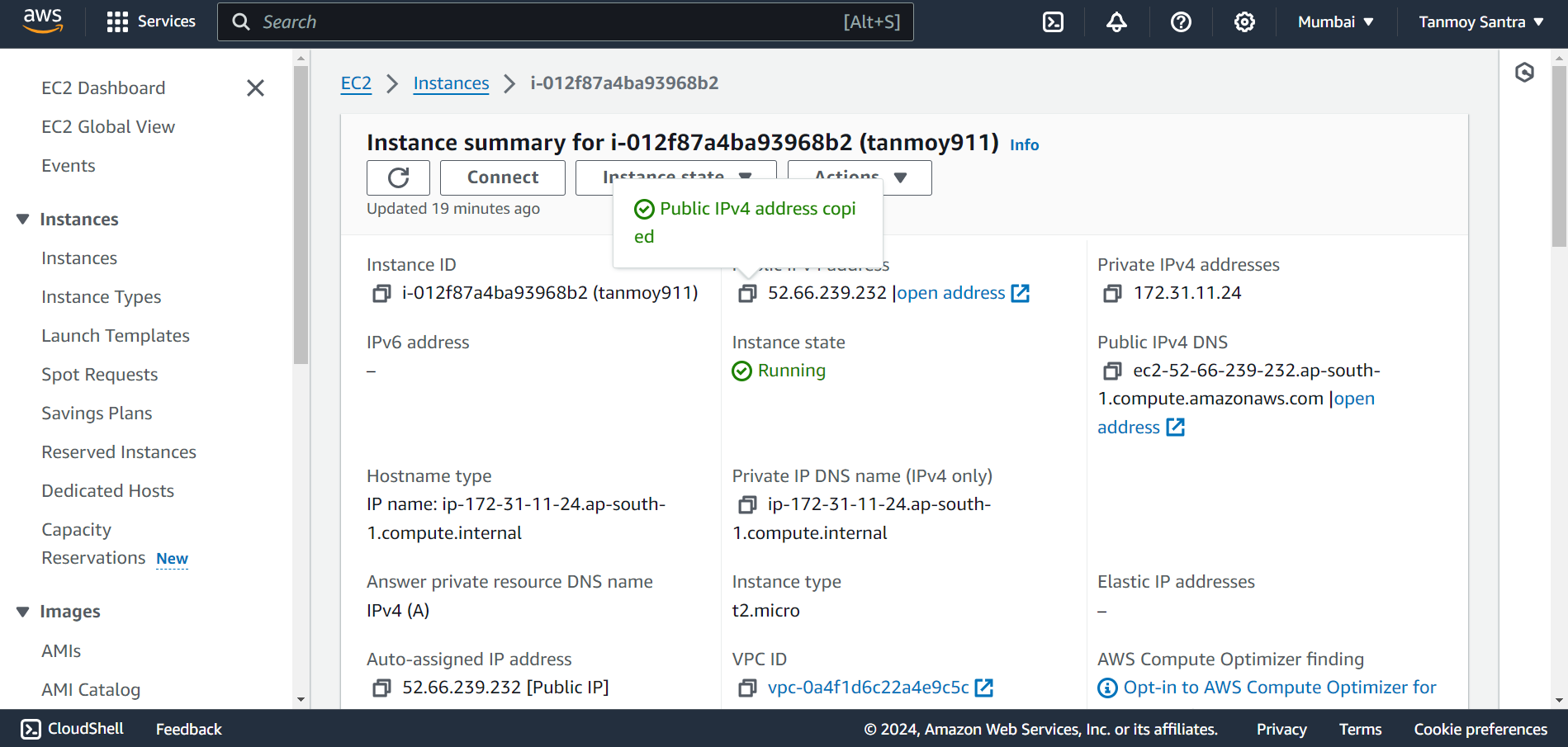

STEP 19- Nginx window will open. Now add :4000 at the end of the IPv4 Address.

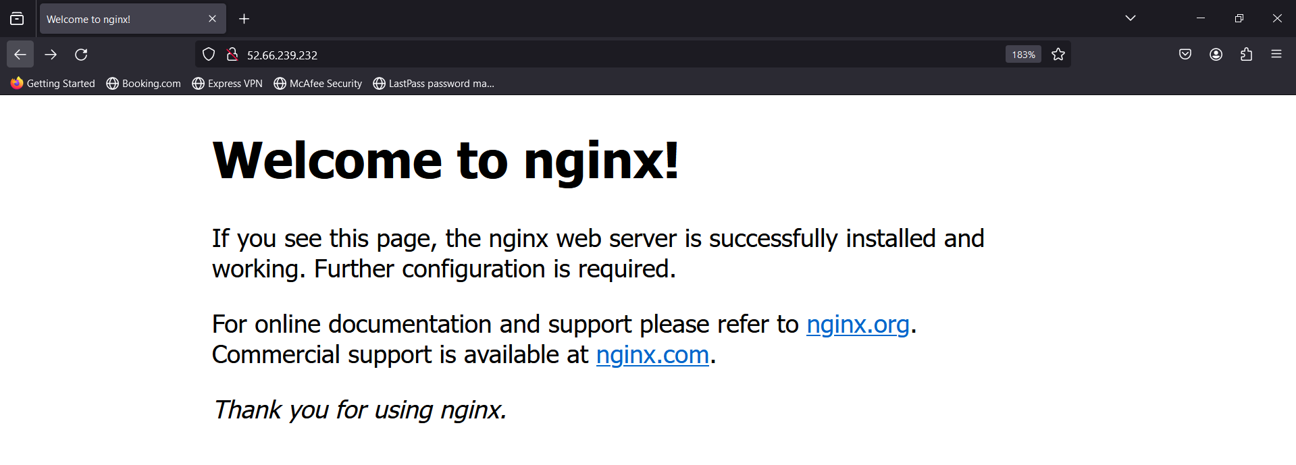

STEP 20- The Nodejs file content will be visible.

